- Details from the Rare Inherited Bleeding Disorders Registry will be presented separately.
- A summary of changes since March 2013 (as at April 15, 2014) is as follows:

 |  |  |  |  |  |  |  |  | 2013-2014
Deficiency | 2007 | 2008 | 2009 | 2010 | 2011 | 2012 | 2013 | 2014 | Incr. | %Incr
VIII | 2435 | 2519 | 2544 | 2626 | 2720 | 2819 | 2934 | 3016 | 82 | 2.8
IX | 595 | 607 | 615 | 632 | 658 | 677 | 696 | 699 | 3 | 0.4
VWD | 2818 | 3066 | 3240 | 3420 | 3536 | 3734 | 3937 | 4059 | 122 | 3.1
Rare Coag | 625 | 714 | 739 | 795 | 824 | 867 | 977 | 1042 | 65 | 6.7
RarePlt | 372 | 500 | 558 | 583 | 631 | 705 | 750 | 821 | 71 | 9.5
C1 Esterase Inhib. | 25 | 30 | 45 | 56 | 65 | 76 | 78 | 101 | 23 | 29.5
Hypogamma. |  | 40 | 64 | 115 | 202 | 253 | 293 | 324 | 31 | 10.6
TOTAL | 6870 | 7476 | 7805 | 8227 | 8636 | 9131 | 9665 | 10062 | 397 | 4.1
HIV + (1985-652) | 226 | 222 | 212 | 209 | 207 | 205 | 202 | 199 | -3 | -1.5

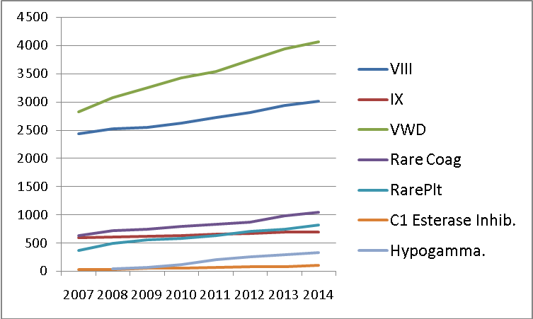

- Recommendations etc.
  - CHR website (ahcdc.ca) will be updated to April 14th
  - HTCs should not submit prior to confirmation of diagnosis
  - A description of CHR and CHARMS is attached.
  - Downloadable forms can be filled online then either printed or “Save as…” for email.
  - Clinics will receive summaries from CHR from Theresa. They can check their CHR data by comparing this summary with the L5 report in CHARMS.

Submitted by Irwin Walker and Theresa Almonte, April 2014.

CHR (Canadian Hemophilia Registry)
CHR is a registry of individuals with hereditary bleeding disorders. It promotes research, educational and administrative objectives. Also, by assigning a number to each patient it facilitates communication across Hemophilia Treatment Centres while preserving privacy.

How does CHR operate?
Individual Hemophilia Treatment Centres (HTCs) submit to CHR anonymous data on affected individuals. The data items, submitted by fax or email, are as follows:
- HTC
- Sex
- Extra Identifier (EXID) - derived from name e.g. John Smith = HNTH
- Other ID code (optional, assigned by the HTC)
- Name of Bleeding Disorder
- Severity or Type (defined)
- Date of Birth

The director of CHR, a member of AHCDC, maintains the above data in a secure server at Hamilton Health Sciences (HHS), assigning a computer generated “CHR number” to each individual. The director returns all of each clinic’s data for checking. Accuracy of data is the responsibility of each HTC.

Privacy and Security of CHR
The CHR system has been approved by the HHS/McMaster Institutional Review Board. The data is accessible only by the director of CHR or his/her assistant. The server is behind the HHS firewall and administered by the IT department. Data Summaries collated on a national basis are transferred to a web page hosted by the Computer Services Unit of McMaster University Faculty of Health Sciences and linked to the AHCDC website (www.ahcdc.ca). Summaries are available to the public.

CHARMS (Canadian Hemophilia Assessment and Resource Management System)
CHARMS is a clinic-based software program designed for the use of individual HTCs, to store and summarize health care-related data required for medical care. The CHARMS system has been approved by HHS/McMaster Institutional Review Board. It is physically separate from CHR; HTCs enter into CHARMS the CHR numbers which are sent separately.

Security of CHARMS Data
Data is stored in the health care institutions in which each HTC resides with no outside access. Demographic data is separated from patient data and encrypted; these data are linked by a computer generated “unique identifier (UI number)”. Access to the demographic data in CHARMS is further locked down by requiring a secondary password.

CHARMS Data Export
- Factor Concentrate Management
Selected data that are anonymous, encrypted and compressed are electronically exported from each HTCto the AHCDC CentrePoint server at HHS, for national analysis. The CentrePoint database is accessible only by the developer, by the analyst at the McMaster University Transfusion Research Program, and by the Administrative Assistant at AHCDC. All individuals have completed health care confidentiality agreements.
A list of data items that are exported from HTCs to CentrePoint is available on request.
Adverse Event Reporting
A preprogrammed routine allows electronic export to Health Canada and the Pharmaceutical Company of data relating to Adverse Event Reporting. This module is available in the Diary section.

Irwin Walker
Cecilia Stiles
September 19, 2009
Revised April, 2014

